**Objective Questions**:

1. What is the total no. of tables present in the data?

2 Tables are in the data.

1. What is the total no. of attributes present in the data?

Total no. of Attributes present in the data is 21

1. How many categorical columns are there in the data? [Search about categorical and continuous data, and try to answer this question]

13 categorical columns in data.

1. The data consists of some inconsistent and missing values so ensure that the data used for further analysis is cleaned.

**Method Used for cleaning the data:**

* Formatting Of Date Column **- Datekey_opening - This date column is not set in the appropriate date format. For formatting the date, used =YEAR(A2) to extract the Year with this date format**
* **Handling Null Values in Cuisine Column:**

**We identified null values in the Cuisine column.**

**Press CTRL + G selected blanks and select the upper value with the help of the arrow button.**

Location – RAW Data Sheet – Column name – Update Cuisines

1. Using the LookUp functions, fill up the countries in the original data using the country code.

Vlookup Function - The common value in the raw data sheet and country description sheet is country code. Therefore, I have used Vlookup (As it looks like the value in the vertical column).

The formula used is:

**=VLOOKUP (C2,'country description’! $A$2: $B$16,2,0)**

1. Create a table to represent the number of restaurants opened in each country.

| **Restaurant Count In Each Country** | |
| --- | --- |
| **Row Labels** | **Count of RestaurantID** |
| Australia | 24 |
| Brazil | 60 |
| Canada | 4 |
| India | 8652 |
| Indonesia | 21 |
| New Zealand | 40 |
| Philippines | 22 |
| Qatar | 20 |
| Singapore | 20 |
| South Africa | 60 |
| Sri Lanka | 20 |
| Turkey | 34 |
| United Arab Emirates | 60 |
| United Kingdom | 80 |
| United States of America | 434 |
| **Grand Total** | **9551** |

1. Also, the management wants to look at the number of restaurants opened each year, so provide them with something here.

| **Restaurant count in Each country year wise** | |
| --- | --- |
| **Row Labels** | **Count of RestaurantID** |
| 2010 | 1080 |
| 2011 | 1098 |
| 2012 | 1022 |
| 2013 | 1061 |
| 2014 | 1051 |
| 2015 | 1024 |
| 2016 | 1027 |
| 2017 | 1086 |
| 2018 | 1102 |
| **Grand Total** | **9551** |

1. What is the total number of restaurants in India in the price range of 4?

COUNTIFS - As the question asks, no. of restaurants in India in the price range of 4. As there are two conditions, so I have used the counties formula to extract the number of restaurants in the price range of 4 in India.

The formula used is:

**=COUNTIFS('1. Raw Data'!$D:$D,"India",'1. Raw Data'!R:R,4)**

Location – Analysis Sheet – question no. 8 mention

**India has 388 number of restaurants in price range 4.**

1. According to the data, what is the average number of voters for the restaurants in each country?

| **Average Voters in Each Country** | |
| --- | --- |
| Australia | 111 |
| Brazil | 20 |
| Canada | 103 |
| India | 137 |
| Indonesia | 772 |
| New Zealand | 243 |
| Philippines | 407 |
| Qatar | 164 |
| Singapore | 32 |
| South Africa | 315 |
| Sri Lanka | 146 |
| Turkey | 431 |
| United Arab Emirates | 494 |
| United Kingdom | 205 |
| United States of America | 428 |

1. Calculate the average rating for all the restaurants that have price_range < 4 and provide online delivery. Use only the “IF” function, Logical Operators, and Aggregation functions to solve this problem. **[Note: Don’t use Conditional aggregation in this question**

**3.27381151**

Formula – Using array formula

**=AVERAGE(IF(('1. Raw Data'!$R:$R<4)*('1. Raw Data'!$O:$O="Yes"),'1. Raw Data'!$V:$V))**

Location – Analysis sheet – objective no. 10

1. Using Conditional formatting highlights the rows of restaurants that are located in the countries or cities that you’ve suggested to the management for opening new restaurants.

**That is highlighted in the Excel sheet name 4. New Opening states & cities**

1. Create a new customized price column that consists of the abbreviation/symbol of the currency along with the Average_cost_for_two values. [Use string operations to do this task]

I first manually compiled a list of current currency symbols. Then, I utilised the **MID & FIND** function in conjunction with the **CONCATENATE** function. This approach allowed me to dynamically associate each currency description with its respective symbol, resulting in a customized column with the desired concatenated information.

Formula –

**==CONCATENATE(MID(M2,FIND("(",M2)+1,FIND(")",M2)-FIND("(",M2)-1),T2)**

Location – Raw data Sheet – Column Name Customized Price Column

1. How can you create an array formula in Excel or Google Sheets to count the number of restaurants listed that do not offer online delivery, are in the lowest price range, and have an average cost for two people less than or equal to 250 Indian Rupees?

To solve this question, I converted the average cost for two, which is in different currencies for different countries, into rupees and then used the array formula.

**Formula used: = {SUM (IF ((('1. Raw Data’! R2:R9552=1) *('1. Raw Data’! O2:O9552="No”) *('1. Raw Data’! U2: U9552<=250)),1,0))}**

In the above formula, **R** represents the **Price range**, **O** represents **Has online delivery,** and **U** represents **Currency updated**.

Location – Analysis sheet – Objective Q no. 13



**Subjective Question:**

1. Suggest a few countries where the team can open newer restaurants with lesser competition. Which visualization/technique will you use here to justify the suggestions?

* **Method used:** I have used a Pivot table, in which rows are country and the value field is the count of restaurant id and average rating. After creating the pivot table, I applied the filter on value fields and selected the bottom 8 values. The reason is I want to select countries with less competition and ratings above 3 but less than 4.
* **Analysis:** After observation, I would suggest countries that come under the condition of less competition with average rating. The reason for choosing an average rating is that if the people in that country are not satisfied with the restaurants and hence the ratings are less. And this thing can be an advantage, we can do a market survey and analyze the reasons why people are less satisfied and we can focus on those things while opening the restaurant.
* Countries Suggested for opening new restaurants: **AUSTRALIA, CANADA, SINGAPORE, SRI LANKA.**

**Location -**

Excel file - sheet name - 4) New opening - state and cities

Table - Suggested Country with ratings

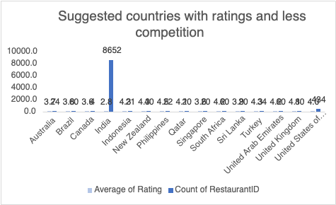

1. Come up with the names of States and cities in the suggested countries suitable for opening restaurants.

* **Method used:** I have used a Pivot table, in which rows are country and City and the value field column is the count of restaurant id and average of rating.
* **Cities selected:**

**AUSTRALIA** -Armidale, Balingup, Flaxton, Macedon, Penola

**CANADA** - Consort, Yorkton

**SINGAPORE** - Singapore

**SRI LANKA** - Colombo

* **Location -**

Excel file - sheet name - 4) New opening - state and cities

Table - Cities in the suggested countries.

1. According to the countries you suggested, what is the current quality regarding ratings for restaurants that are open there?

| **Suggested Country With Ratings** | | |
| --- | --- | --- |
| Australia | | 3.66 |
| Canada | | 3.58 |
| Singapore | | 3.58 |
| Sri Lanka | | 3.87 |

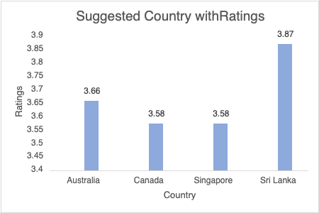

Among these, **Sri Lanka** has the highest average rating for restaurants at **3.87** indicating a better quality experience overall compared to the other countries listed. Conversely, **Canada** and **Singapore** have the same average rating of **3.58** reflecting a relatively similar quality level. **Australia** falls in between at **3.66** offering a moderate quality experience.

**Location:**  Excel file - Sheet name - 4) New opening - state and cities

Table - 3) Suggested country with rating

1. Also, what is the current expenditure on food in the suggested countries, so we can keep our financial expenditure in control?

* **Method used**: I have used the aggregated function that is SUMIF function to find the total expenditure in the suggested country.

* **Formula used:**

=SUMIF('1.RawData'!D:D,"Australia",'1.RawData'!T:T)*'1. Raw Data'!AD12

* **Current Expenditure on Food:**

Australia - 31,229

Canada - 12,087

Singapore - 1,91,884

Sri Lanka - 13,300

* **Visualization method used**: Pie Chart

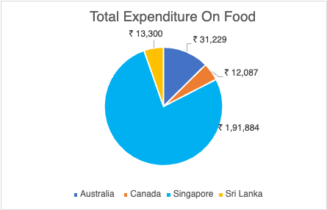

* **Location:**

Excel file -sheet name - 4) New opening - state and cities

Table - 4) Total expenditure on food

1. Come up with the names of restaurants from the recommended states that are our biggest competitors and also those that are rated in the lower brackets, i.e. 1-2 or 2-3.

* **Method used:** I have used four pivot tables for all four countries. In the row section Country and Restaurant, the name is there, in the filter section city, and in the value, the field sets an average of rating and an average of the cost of two in Indian currency.

Based on rating and cost the competitors are evaluated.

* **Restaurants that are biggest competitors:** These are marked in green in the Excel file. These biggest competitors have the highest ratings.
* **Restaurants that are rated low:** This category has been subdivided into two. One which is marked in yellow is the restaurants which are having average ratings. The second category marked in red is the restaurants that are in the lowest bracket with the lowest ratings.
* **Location -**

Excel file - sheet name - 5) Competitor Analysis

1. Which cuisines should we focus on in the newer restaurants to get better feedback? Does the choice of cuisines affect the restaurant ratings?

* The choice of cuisines - Affect the ratings as every country has its own local food choices and preferences. For example, if you are selling food in another country, it would not sell as much as it would sell in Australia.
* Basis for suggestion - The basis I have taken the ratings. The restaurants with cuisines which are local to that country are high in rating and other than this other food preferences which are famous in all countries are like seafood, Italian.
* Decision - By observing the pivot table, I analyse that some cuisines like seafood have very high ratings due to their popularity in that country. The decision that cuisine affects the rating is based on the observation. These analyses provide a starting point for understanding trends and patterns in the data, allowing us to make informed decisions and improvements in the restaurant business based on customer feedback and preferences.
* Location:

Excel file - sheet name - 6) Cuisines Analysis

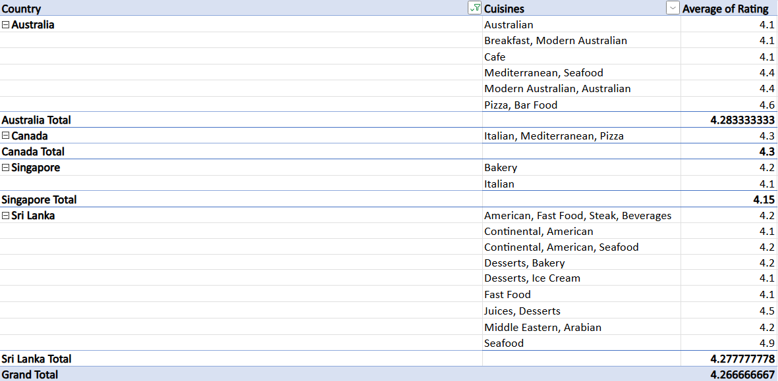

7. According to our current data, should we go for online delivery and table booking? Does that affect the customer’s ratings? Mention your approach and spreadsheet function for the answer.

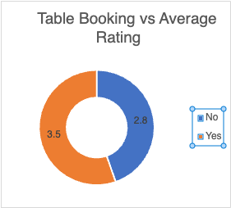

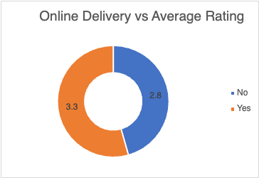

Table Booking Impact:

* Without table booking: Average rating is 2.8.
* With table booking: Average rating is 3.5.
* Conclusion: Table booking increases the average rating significantly.

Online Delivery Impact:

* Without online delivery: Average rating is 2.8.
* With online delivery: Average rating is 3.3.
* Conclusion: Online delivery also improves the average rating though to a lesser extent than table booking.

Yes, the data suggests that enabling **table booking** and **online delivery** improves customer satisfaction, as reflected in higher ratings. Both features cater to convenience and enhance the dining experience which positively influences ratings.

* **Location** -

Excel file - sheet name - 7) Delivery Analysis.

8. Should the team keep the rate of cuisines higher? Will that affect the feedback? According to our data are the rates of cuisines and ratings, correlated?

* **Method used**: I have used the function to find the correlation between the rate of cuisines and ratings
* **Decision:** A value close to 1 (like 0.8078) suggests that as the rate of cuisines increases, the ratings tend to increase as well.Customers may associate higher prices with better quality presentation or exclusivity of the food leading to better feedback.
* Formula: **=CORREL($D$4:$D$36,$E$4:$E$36)**
* **Location:** Excel File - sheet named - 8) Correlation

9.What is the distribution of the number of restaurants of different price ranges in all the countries?

* **Method used:** I have used a Pivot table, in which rows are price ranges and the value field is the count of restaurant IDs.
* **Distribution of restaurants in different price ranges:**

1-: 4444

2-: 3113

3-: 1408

4-: 586

* **Location:** Excel File - sheet named: 9) Price range

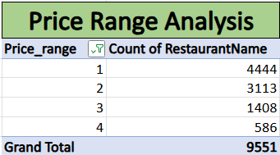

10.Explain your approach in brief for suggesting countries/cities to open new restaurants, if the objective and subjective questions would have been given to assist you. **[you have to give bullet pointers to answer this question]**

**Countries Suggested (Australia, Canada, Singapore, Sri Lanka):**

**Analytical Criteria:**

* Utilized Pivot tables with restaurant count and average ratings.
* Applied filters for low competition and ratings below 4.

**Strategic Insights:**

* Identified regions with both low competition and potential for improvement in average ratings.
* Focused on countries where market entry could yield substantial benefits.

**City Selection:**

**Analytical Criteria:**

* Employed a similar Pivot table approach on city-level data.
* Focused on cities within suggested countries with low competition and ratings less than 4.

**Strategic Insights:**

* Choose cities aligning with the overall country criteria.
* Aimed for a balanced selection of cities within the recommended countries based on data analysis.

**The dashboard must consist of Year-wise and country slicers.**